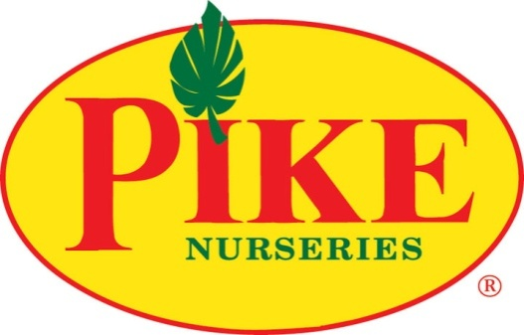

FOR MORE INFORMATION:
Laurel Haislip/Becca Meyer
BRAVE Public Relations, 404.233.3993
lhaislip@bravepublicrelations.com/
bmeyer@bravepublicrelations.com

FOR IMMEDIATE RELEASE

Pike Nurseries selects Charlotte market for expansion

Nation’s largest independent garden retailer set to open third Charlotte location in Lake Norman this spring

ATLANTA (January 12, 2018) – Garden retailer, Pike Nurseries, is pleased to announce plans for expansion in the Charlotte, N.C. area. In late March, the well-known and respected southern gardening retailer will plant its third store in the Charlotte market near Lake Norman. Offering local residents superior horticultural knowledge, a quality selection of plants and outdoor accessories and a lifetime guarantee on all tress and shrubs, Pike Nurseries is the go-to garden center for all landscaping needs.

The new Charlotte store will serve as the 18th location for Pike Nurseries, a full-service garden company that offers trees, shrubs, perennials, vegetables and more -- as well as a collection of lifestyle products such as pottery, fountains, patio furniture and birding supplies. Known for their knowledgeable local garden experts at all locations, the garden centers also provide landscape design, installation and planting services to help homeowners as much or as little as they would like in their gardens.

“Pike Nurseries has received an overwhelming amount of support in the Charlotte market, and we are thrilled to add a third location for our loyal customers,” said Mike Kunce, Pike Nurseries CEO. “Charlotte’s growth in recent years has demonstrated an increased interest in horticulture among residents looking for the best selection and expert advice. This new store is primed to serve the Lake Norman community with our signature variety, selection and knowledgeable Pike Nurseries team.”

Located at 18234 Stateville Rd. in the suburb of Cornelius, the new 40,000 square foot store will offer a wide assortment of seasonal annuals, perennials, shrubs, trees, houseplants, patio furniture, garden décor, landscape services and more! Pike Nurseries will be seeking employees for the new store, including positions in sales, maintenance and loading. Interested candidates are encouraged to attend the Pike Nurseries Career Fair on January 17 from 1-4 p.m. at the Pike Nurseries’ Matthews location located at 1016 Devore Lane to learn about position descriptions, qualifications, benefit information and to pick up an application.

For more information about the career fair, visit please visit Pike Nurseries online at pikenursery.com or connect on Facebook, Twitter, Pinterest and Instagram.
###
ABOUT PIKE NURSERIES
Ever committed to its customers’ gardening success, Pike Nurseries takes pride in taking the guesswork out of gardening and helping its customers play in the dirt. Offering superior knowledge, quality and selection in a friendly, caring environment, Pike Nurseries has been an Atlanta icon for over 60 years. Founded in 1958 by Pete Pike, its ability to adapt to market conditions and community needs has made it a respected Southern institution. As Atlanta’s oldest garden chain, Pike Nurseries has 17 retail locations in the Atlanta, Ga. and Charlotte, N.C. areas. Now led by CEO Mike Kunce, Pike Nurseries looks forward to continued growth as it keeps Atlanta and Charlotte beautiful, one landscape at a time.

